Low Level Design (ADD PERSONAL DETAILS module)

Project Code | Team2
Project Name | Online Recruitment Management System

Prepared/Modified by | Role | Date of Preparation
Akash Bansal | Senior Software Analyst | 11/11/2017
Reviewed by | Role | Date of Review
Vaishali Srivastava | Consultant | 16/11/2017
Approved by | Role | Date of Approval
Vishal Mali | Senior Consultant
Circulation List | akash.bansal@capgemini.com,  mvallamk@capgemini.com,  kaustav.saha@capgemini.com,  mohit.deshmukh@capgemini.com | Version Number of the template:1.0
Version Number | 1.3

Table of Contents

1. Description Of The Unit 3
2. References 4
3. Dependencies / Assumptions 5
4. Class Diagrams 6
5. Sequence Diagrams 7
6. Design Components 8
6.1 List Of UI Components 8
6.2 List Of Design Classes 8
7. Re-Usable Routines/Components 9
8. Messages 10
9. Configuration Files 11
10. Crud Matrix Table 12
11. Data Mapping Matrix 13
12. Action Flow Matrix 14
13. Stored Procedures 15

Description Of The Unit

The add personal details module allows the candidate to add personal details into the database.This functionality is only for candidate.

On clicking the add resume button, candidate is given a list of options. Now, on clicking add personal details link, a form is displayed just below the link. Candidate has to fill the form adhering to the proper validations and then click on the save button in order to save the personal details to the database.
If candidate clicks on save button, the Candidate personal details are inserted into the database and the candidate is again redirected to same page to add other details.
If not inserted, user will be redirected to an error page.

References

Reference | Description
Repository reference | https://github.com/mvallamk/Group-2_OnlineRecruitmentSystem/tree/master/OnlineRecruitmentSystem-Group-2
Class Diagram | /Project Documents/Design Documents/HLD/Class Diagrams
URS | /Project Documents/Requirements/Case Study/OnlineRecruitmentManagementSystem.doc
UTP | /Project Documents/Test Plan/UTP/Test Cases/AddPersonalDetails/UTP_AddPersonalDetails_Module.xlsm
DB Design | /Project Documents/Design Documents/HLD/DB Design/OnlineRecruitmentManagementSystem.xls

Dependencies / Assumptions

Dependencies:
The user has already logged in.

Assumptions:
The login details are already present in the database.

Class Diagrams

Class Diagram

Sequence Diagrams

Sequence Diagram
NA

Design Components

List Of UI Components
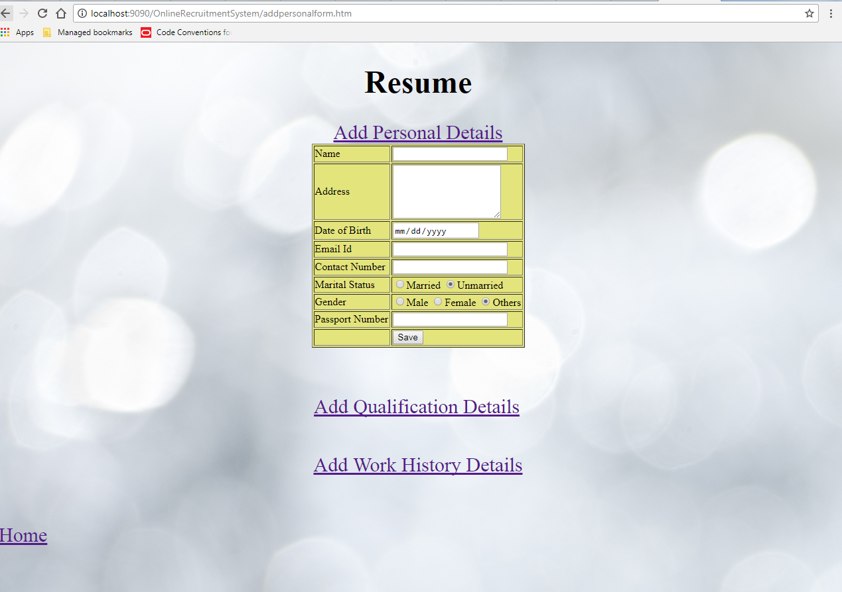

List Of Design Classes
Sr. No. | LLD Name | Class Name | Method Name | Method Description
1 | Add Personal Details  Module | CandidatePersonal | Appropriate getters and setters methods | Getters retrieve the property values and setters set the property values
2 | Add Personal Details  Module | RecruitmentController | addPersonalForm(Model model):String  savePersonal(@ModelAttribute("candPers") CandidatePersonal candidatePersonal ,Model model):String | Sets the model attribute.  Calls candidPersonal() of RecruitmentServiceImpl class. If no exception occur, it will show home page else it redirects to error page with appropriate error message
3 | Add Personal Details  Module | RecruitmentServiceImpl | candidPersonal(CandidatePersonal) | candidPersonal() of RecruitmentDAOImpl class.
4 | Add Personal Details  Module | RecruitmentDAOImpl | candidPersonal(CandidatePersonal) | Inserts the candidate personal details into the database

Re-Usable Routines/Components

Re-Usable Routines/Components

- CSS files
- Javascript files
- DataAccessException class
- Database xml files
- Logger properties files

Messages

#. | Type | Message Text
M1 | Error | Personal Details already stored. Modify them

Configuration Files

File Name | Path | Description
jpaContext.xml | /Development/Source/OnlineRecruitmentSystem/resources | To configure database connection.
web.xml | /Development/Source/OnlineRecruitmentSystem/WebContent/WEB-INF | To configure the bean properties and request mapping.
servlet-config.xml | /Development/Source/OnlineRecruitmentSystem/WebContent/WEB-INF/config | To configure view resolver.
log4j.properties | /Development/Source/OnlineRecruitmentSystem/resources | To configure the logger.

Crud Matrix Table

# | Table Name | Create | Read | Update | Delete
1. | CandidatePersonal | Y | N | N | N

Data Mapping Matrix

Sr. No. | Screen Label | Field Source | Field Type | Data Type | Max Length | Data Flow | Mandatory
1 | Name | NA | Label | NA | NA | UI | NA
2 | txtCandidateName | CandidatePersonal.candidateName | TextBox | Varchar2 | 20 | UI→D | Yes
3 | Address | NA | Label | NA | NA | UI | NA
4 | txtAddress | CandidatePersonal.address | TextBox | Varchar2 | 10 | UI→D | Yes
5 | Date of Birth | NA | Label | NA | NA | UI | NA
6 | dateDateOfBith | CandidatePersonal.dob | Date | Date | NA | UI→D | Yes
7 | Email ID | NA | Label | NA | NA | UI | NA
8 | txtEmailID | CandidatePersonal.emailId | TextBox | Varchar2 | 30 | UI→D | Yes
9 | Contact Number | NA | Label | NA | NA | UI | NA
10 | txtContactNumber | CandidatePersonal.contactNumber | TextBox | Number | 10 | UI→D | Yes
11 | Marital Status | NA | Label | NA | NA | UI | NA
12 | optMaritalStatus | CandidatePersonal.maritalStatus | RadioButton | Varchar2 | NA | UI→D | Yes
13 | Gender | NA | Label | NA | NA | UI | NA
14 | optGender | CandidatePersonal.gender | RadioButton | Varchar2 | NA | UI→D | Yes
13 | Passport Number | NA | Label | NA | NA | UI | NA
14 | txtPassportNumber | CandidatePersonal.passportNumber | TextBox | Varchar2 | 8 | UI→D | Yes
15 | Cancel | NA | Button | NA | NA | UI | NA

Legend
D → UI (Database to User Interface)
UI → D (User Interface to Database)
UI (User Interface Only)

Action Flow Matrix

Sr. No. | Action | Description | Process
1 | On click of Add Personal Details link on AddResume Page | Opens up the Add Personal Detail form | The candidate clicks on the add resume button and a form with personal details will open just below the link
2 | On click of Save button on AddResume page | The personal details are inserted into the database. | Data is entered in the fields by the candidate which gets inserted into the database when save button is pressed.

Stored Procedures

# | Stored Procedure Name  (with Description) | Input/Out Parameters | Type | Size
1. | NA | NA | NA | NA

